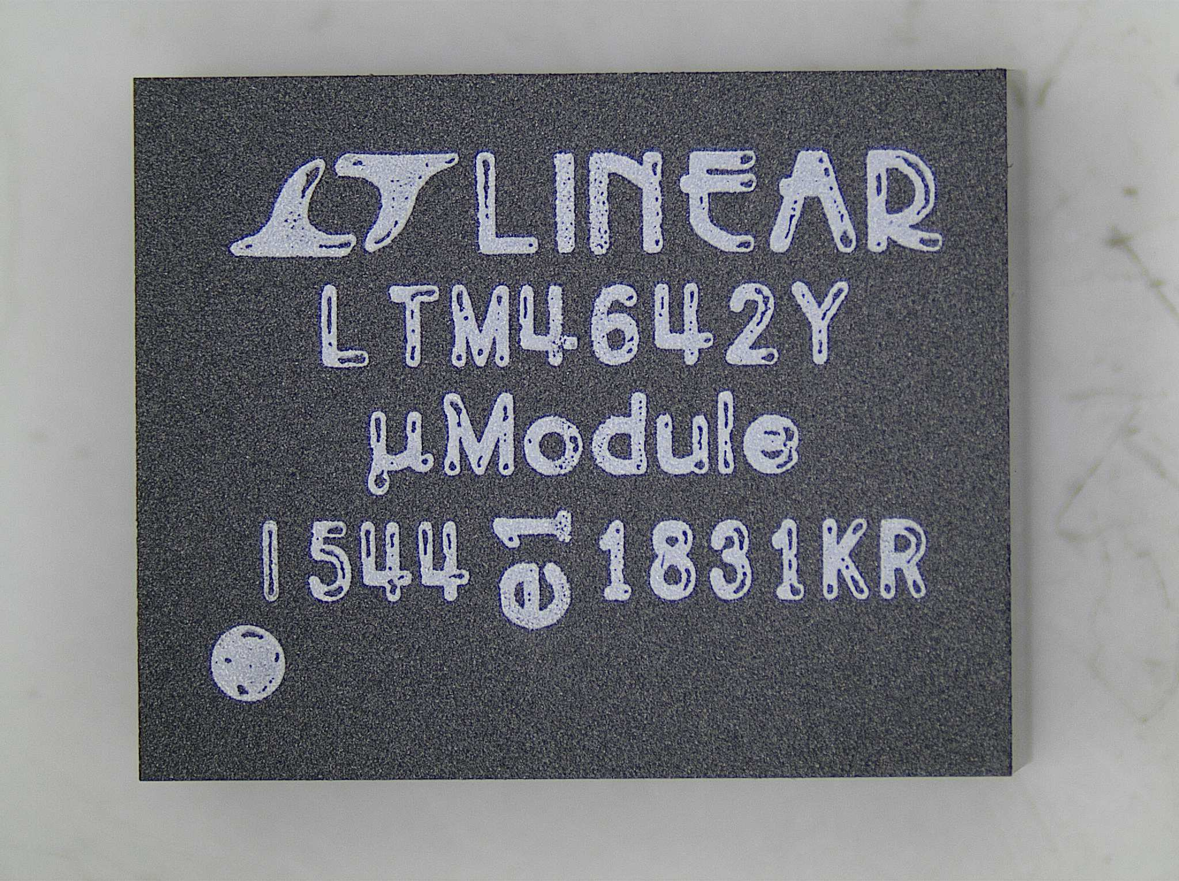
Sample of Top Mark on LTM4642

